Databases – Pallet Database:

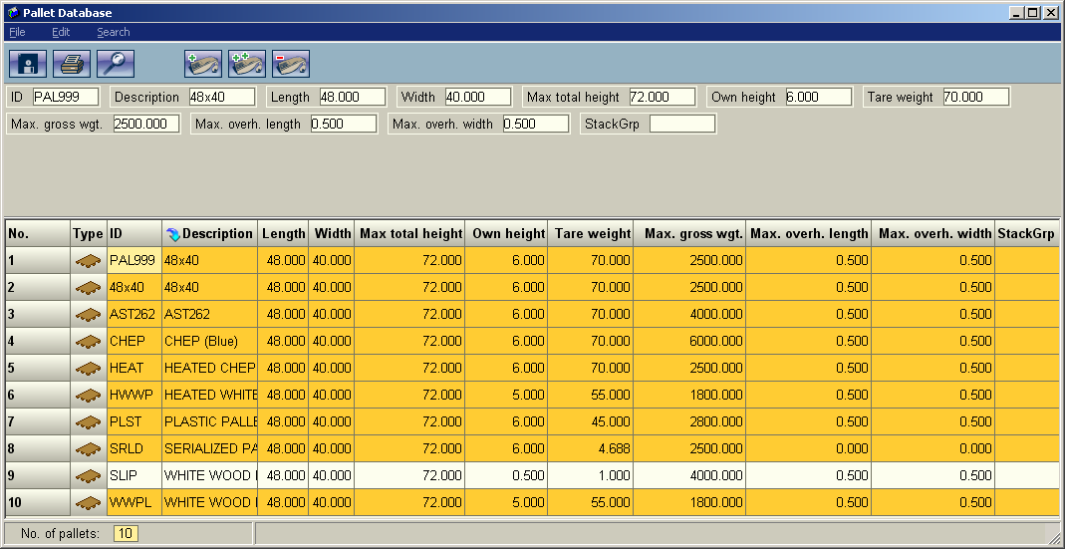

A list of "Assets" that load designer can use to look up dimensions and weight restrictions.

Relevant Fields:

ID: Needs to match asset_type's in the WMS exactly.

Description: A brief description of the asset.

Length: Length of the Pallet

Width: Width of the Pallet

Max total height: How tall a pallet on this type of asset can be. Not used when a full pallet is sent over.

Own Height: How tall the asset is.

Tare Weight: The weight of the asset by itself

Max Gross Weight: The maximum allowable weight of the asset and product that is on it.

Max Over Hang: The maximum distance product can over hang the side of pallet.

StackGrp: Not Currently Used by RedPrairie.

